Electric management system

AUTHORS:

HEMANTH BOINIPALLY

DIYA

ASHISH

TABLE OF CONTENTS:

1. Mission statement
2. stakeholders
3. Key Drivers
4. Key Constraints
5. Problem’s Fit to Life-Cycle
6. Functional Requirement
7. Use Case Modeling
8. Architecture
9. Non-Functional Requirements
10. Object Class Diagram
11. Test and Evolution Planning
12. Measurement Plan
13. Estimating Effort
14. Reliability and Availability Requirements
15. Safety, Security and Resilience

MISSION STATEMENT

* There is a problem with supplying electricity to all parts of the world; to address this, we are developing a project that will allow us to use renewable energy to supply it to various parts of the world at a low cost and with ease of access; we are considering homeowners who have unused energy as vendors and homeowners who cannot access electricity as lenders; the vendors can lend the power from solar panels, generators, and other sources.
* Using solar panels would assist to reduce air pollution, water usage, reliance on nonrenewable energy sources, and improve long-term human health.

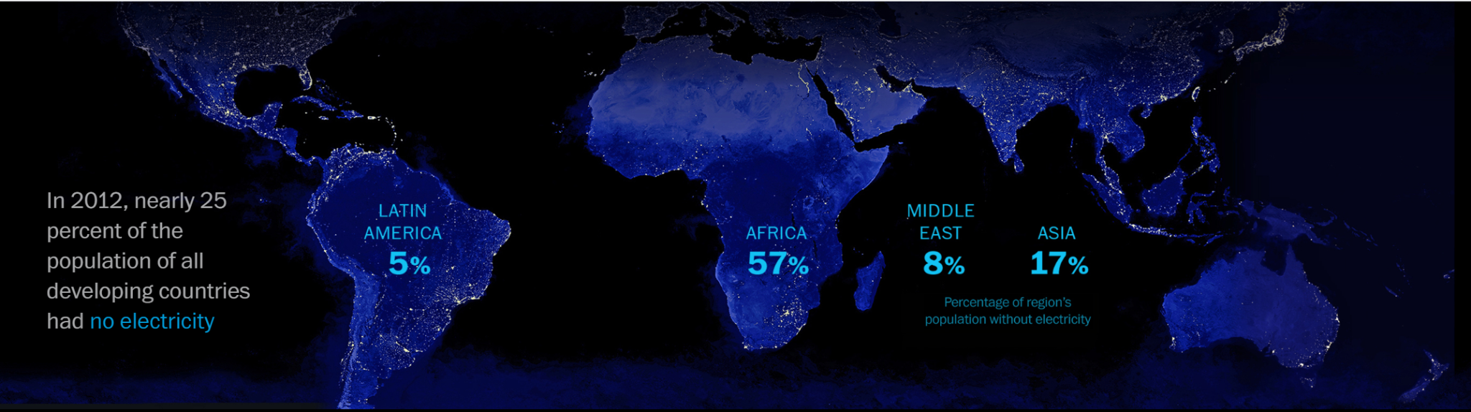

**STAKEHOLDERS**

**Internal Stakeholder:**

* An internal stakeholder is a person or group who is affected by a business process.
* An internal stakeholder is a person or group who genuinely cares about a project.
* What is the function of a stakeholder in the discussion about An internal stakeholder is said to be employed in the decision-making process.
* This procedure involves huge corporations, government entities, and non-profit organizations.

**External Stakeholder:**

* The primary job of internal stakeholders is to invest in or exit a business. External stakeholders, on the other hand, have little influence over the company's operations.
* Do not participate in any company's internal matters, as you may have guessed from the names of external stakeholders.
* **Internal Stakeholders** :-
* UI/UX Developers:UI/UX designers are in charge of designing and implementing all of the experiences that a user has when dealing with a digital tool, such as a website. The user interface/user experience designer will collaborate closely with our marketing team and designers to guarantee seamless web/mobile design and the successful implementation of UI/UX best practices and principles across all of our digital platforms. UI/UX designers are in charge of designing and implementing all of the experiences that a user has when dealing with a digital tool, such as a website. The user interface/user experience designer will collaborate closely with our marketing team and designers to guarantee seamless web/mobile design and the successful implementation of UI/UX best practices and principles across all of our digital platforms.
* Q/A Engineers:Quality assurance is the primary function of QA. A QA engineer is responsible for enhancing software development processes and preventing production problems. In other words, they ensure that the software development team is doing things correctly. The job description of a QA engineer includes a variety of responsibilities. Checking if the product complies with the requirements,Assessing risks,Planning ideas to improve product quality,Planning tests, Analyzing the test results
* Developers: developers have to do works like Software research, design, implementation, and management,New program testing and evaluation,Identifying areas for improvement in existing programs and then implementing these improvements,Writing and deploying effective code,assessing operational feasibility,Creating methods for quality assurance,Putting software tools, processes, and measurements in place,Existing systems must be maintained and upgraded.,User education,Collaboration with other developers, UX designers, business analysts, and systems analysts
* Project Managers:Project managers are in charge of planning and supervising projects to ensure they are finished on time and within budget. Project managers plan and allocate project resources, create budgets, track progress, and keep stakeholders updated throughout the process. All of this is done within the framework of a company's goals and vision. Project managers are needed for a wide range of initiatives, including construction, information technology, human resources, and marketing.
* Business Analysts:A business analyst is an essential member of any project team. They gather information, document processes, and confirm final documents with users as the primary interaction between users and the project manager.
* **External Stakeholders :-**
* Customers:
* End Users
* Government
* Suppliers
* Sales Supervisor
* Marketing Team
* Customer Service Team
* Installation Companies
* Component Manufacturers
* Roofers
* HVAC installers

**Key Drivers**

Key drivers are the most important aspects influencing a company's or business's performance. A major driver is something that has a significant impact on how well the business performs. It can also provide early warning indicators of poor performance or outcomes. Let's take a look at some crucial driver selection recommendations and examples.

* Number of locations: as the business is about solar energy the manufacturing plants are meant to be opened at every major country like USA, RUSSIA, CHINA,UK,INDIA as we can find skilled and unskilled workers with ease and has population with good literacy rate where they can understand the concept and has the idea about the solar panels. However,our target is to get electricity to the rural areas more so, we will have stores opened near them and we have sales site where can people can get our products from any spot in world
* Traffic volume to your business website:Website traffic refers to the number of people who visit a website. Web traffic is measured in visits, sometimes known as "sessions," and is a standard approach to assess an online business's ability to attract customers.When ecommerce initially took off in the 1990s, web traffic was seen as the most crucial statistic for measuring a website's popularity because alternative metrics to gauge online performance did not yet exist. Analyzing a website's performance becomes far more detailed as digital marketers become more savvy.
* Effectiveness of the sales team;”:Sales effectiveness = output per salesperson.”George bronten following this statement , our sales team has best effectiveness compared to regular industry standards . they did plan to educate rural people of pros of our business and are contacting social media influencers as advertising means due to budget constraints and they would reach corner of the globe very easily
* Number and price of offerings: as we are planning to sell our products all over the world. The pricing would be different for every place . as there are different manufacturing costs in each place. For example, India has low manufacturing cost and labor costs compared to the USA or Canada. So, the selling cost would be low too .as the cost of living is also low in india we should sell our product accordingly.
* Customer satisfaction: customer plays an important role in the business because he is the final destination for any company. Mouth publicity plays a major role in the business .so, we have given out our product to some influential people all over the world and some to some volunteers as beta testers and we have got a great response from them
* Staff turnover: as the company is on a global scale we need a lot of unskilled labor and quite a number of skilled labor .where the unskilled workers' pay range would be between 5,000 dollars to 50,000 dollars and skilled workers' pay range would be ranging from 25,000 dollars to 125,000 dollars. there is sales team who will also be in range of skilled workers

**Key Constraints:**

**User stories:**

## **Problem’s Fit to Life-Cycle Process**

The reliability and stability of electricity in some parts of the world is under high variance. Our Management System product will help alleviate some of the problems and bring peace of mind to both homeowners and business people.

**Tentative Solution:**

Our product will be a small device that will need to be installed and connected to the local power grid that will analyze the fluctuation of electricity in order to procure a steady output of power for the building.

**Development Strategy:**

The software will be developed in an iterative, Agile-like manner. Due to this being a small to medium sized project, and that there may be many currently unforeseen problems or changes, developing the product iteratively will help us overcome the challenges with less wasted effort and time.

**Targeted Users:**

The intended customer for our solution will be homeowners and small businesses. The reason for this is that for many of these potential customers, having high variance and unpredictability in their power system can be more detrimental than for people with larger capital and more resources. Also, these buildings are more likely to be surrounded by buildings that also have power issues, and diverting excess power and stabilizing the overall grid will be more beneficial to the neighborhood or small community.

**Deployment Strategy:**

We intend on delivering our product to low importance buildings and delivering to many buildings in the area in order to have a safety net in case some of the devices fail. In this case some of the devices in the neighborhood can take the load temporarily meanwhile a technician/homeowner sees what they can do to fix the problem.

* Our product will allow for the attachment of additional power sources like solar panels. Many homeowners consider putting solar panels on their houses in order to produce more electricity, lower their electricity bills, and to lower the effect main power grid fluctuations have on them.
* Our product must accommodate these modifications in order to be marketable to these people.

**Development Environment & Tentative Output:**

* Our product will be inside a small Linux device that will connect to the building's power grid.
* Our product will be a single device managing one building’s power grid while also being able to communicate to other similar devices.
* The device will be connected to the internet and be able to download and install updates on a set period.
* The user will be able to access a limited management portal for the device through the web. Technicians will have full access to the device and will monitor its health on a periodic basis.
* The device will self report a set amount of information that it will store locally. Periodically it will send the reports to the web service. Users will be able to download their devices reports over the internet from anywhere.

## **Functional Requirements**

**UML Use Cases**

* 1. **ID:** EMS01
  2. **Name:** Homeowner can view how much power their system produces
  3. **Actors:** Homeowner, system
  4. **Description:** 
     1. System keeps track of how much power is being produced
     2. Homeowner views the information
  5. **Response:** Power production of the system
  6. **ID:** EMS02
  7. **Name:** Homeowner can view how much power is being diverted
  8. **Actors:** Homeowner, system
  9. **Description:** 
     1. System keeps track of how much power is being diverted
     2. Homeowner views the information
  10. **Response:** Power diversion of the system
  11. **ID:** EMS03
  12. **Name:** The system can notify the homeowner when an error occurs
  13. **Actors:** System, homeowner
  14. **Description:** 
      1. An error occurs in the system
      2. System alerts the homeowner
  15. **Response:** The homeowner is notified about risen errors
  16. **ID:** EMS04
  17. **Name:** The system shall be able to charge a battery with excess power
  18. **Actors:** System, battery
  19. **Description:** 
      1. The system detects excess power being produced
      2. System reroutes power to batteries
  20. **Response:** The battery being charged with excess power
  21. **ID:** EMS05
  22. **Name:** The system shall be able to sell power to the power company when battery if full
  23. **Actors:** System, battery, power company
  24. **Description:** 
      1. System monitors battery level
      2. When battery becomes fully charged, start drained and selling the power to the power company
  25. **Response:** Power from the battery being sold to the power company
  26. **ID:** EMS06
  27. **Name:** The system shall not sell power once battery as below a set threshold
  28. **Actors:** System, battery
  29. **Description:** 
      1. User sets up a threshold below which the battery shall not be drained in order to sell excess power
      2. System monitors battery level
      3. System stops battery drain once threshold is reached
      4. System does not resume drain once battery is fully recharged
  30. **Response:** Battery storage does not fall below a set threshold

## **Use Case Diagram**

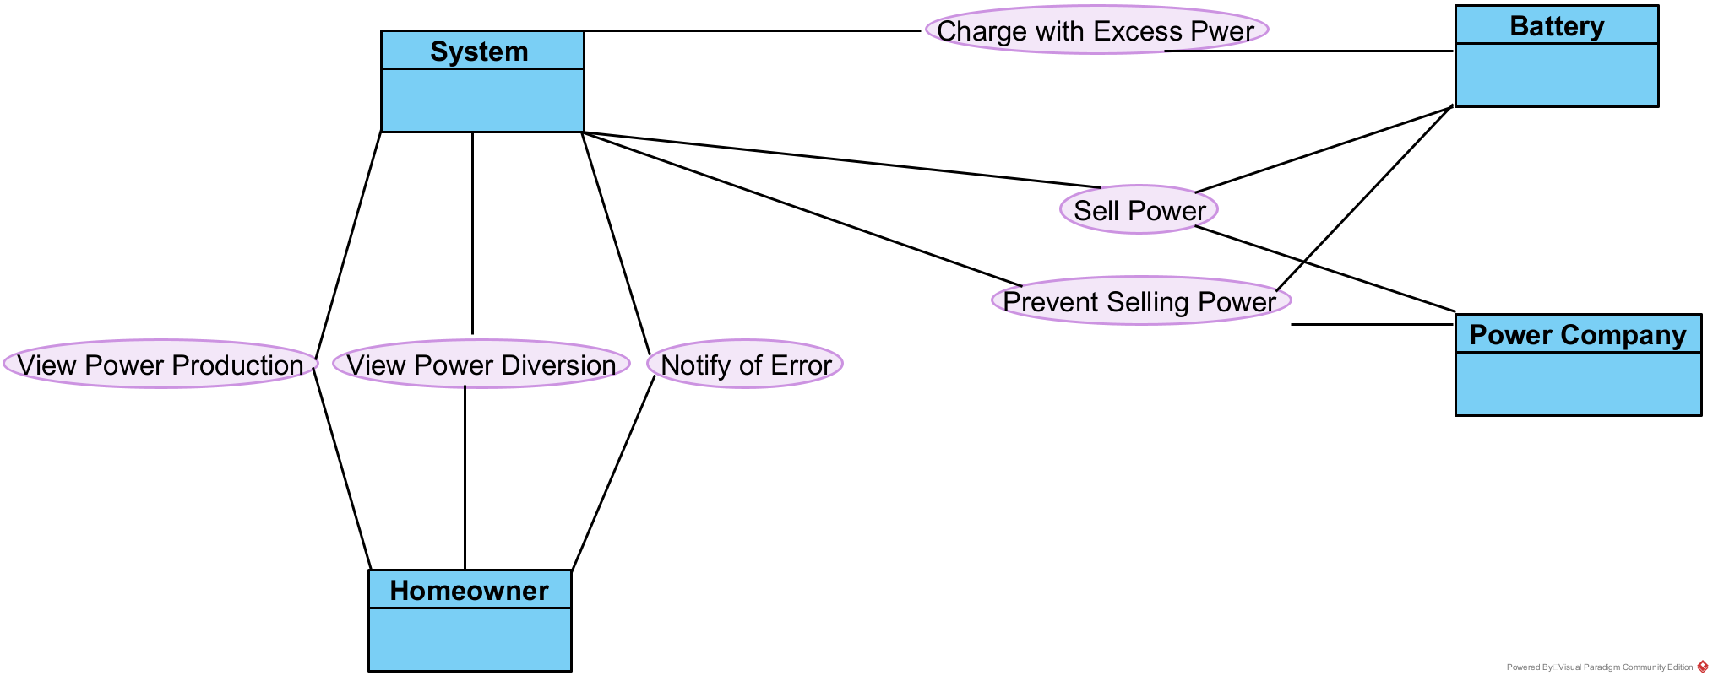

**Use Case Modeling**

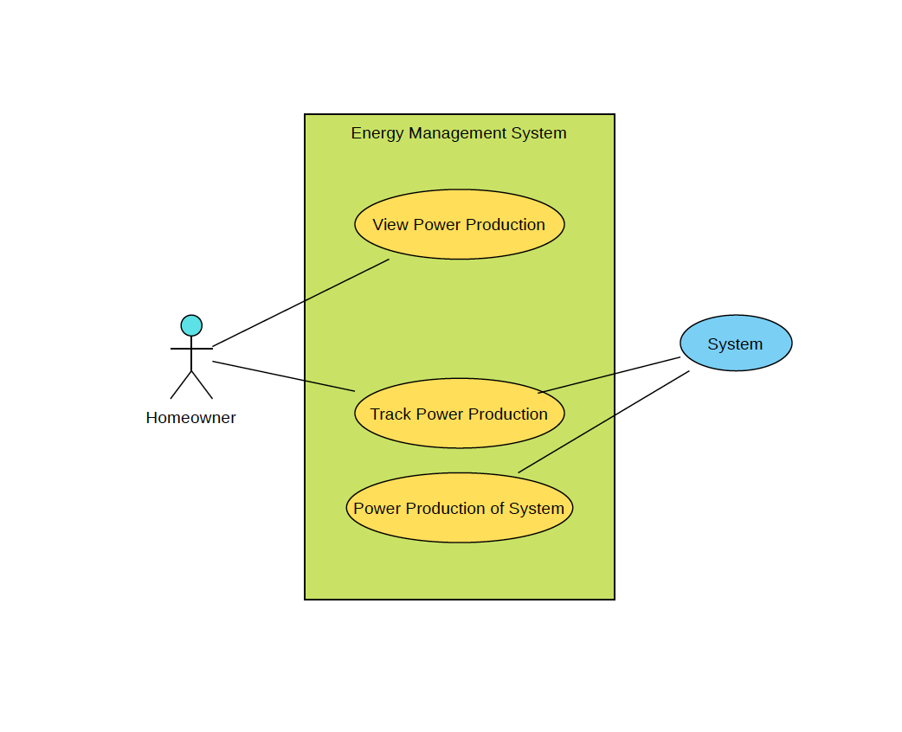

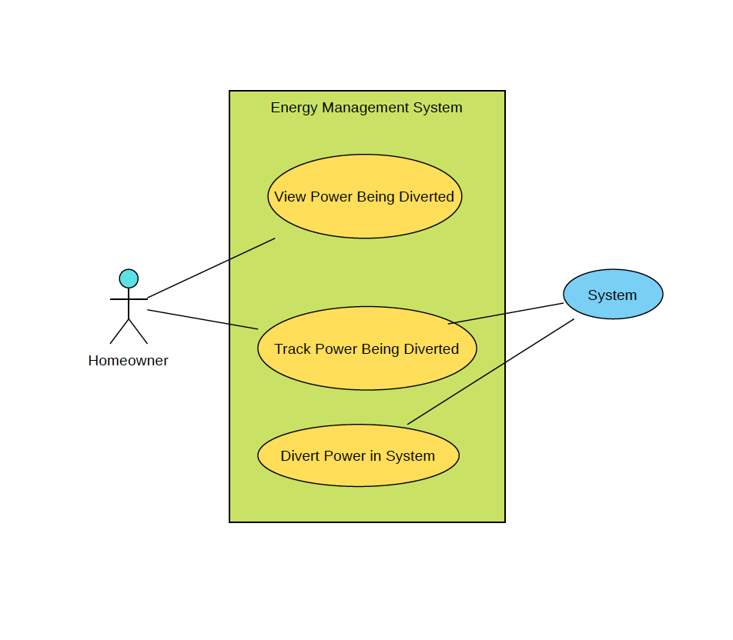

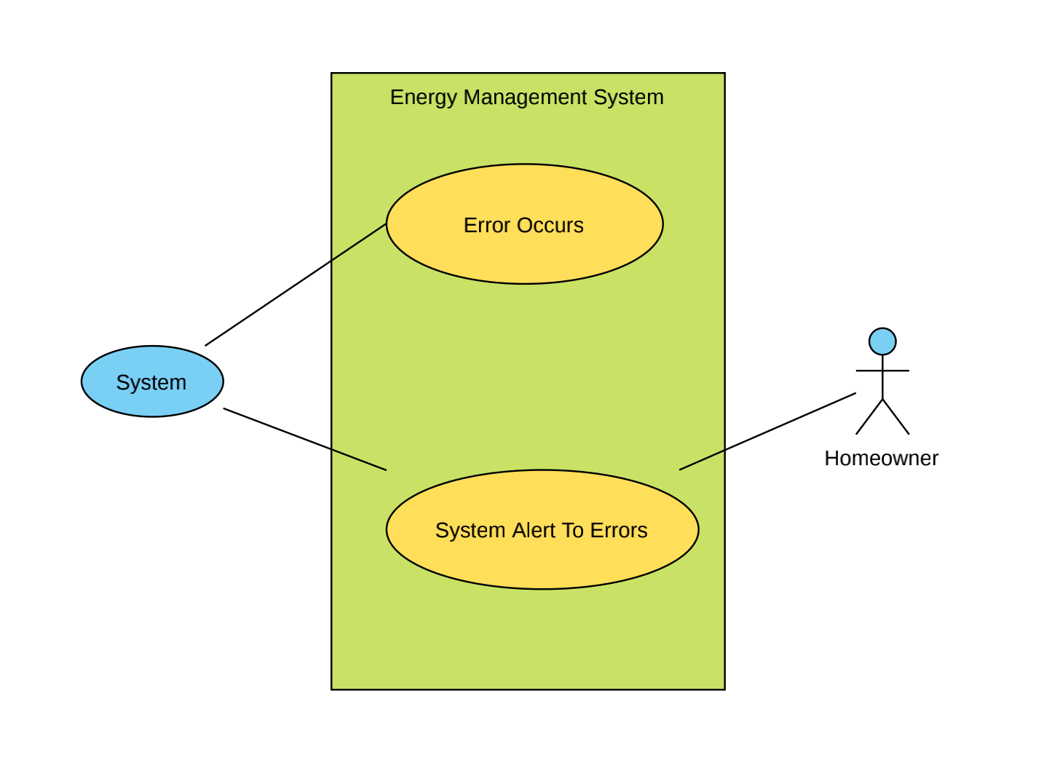

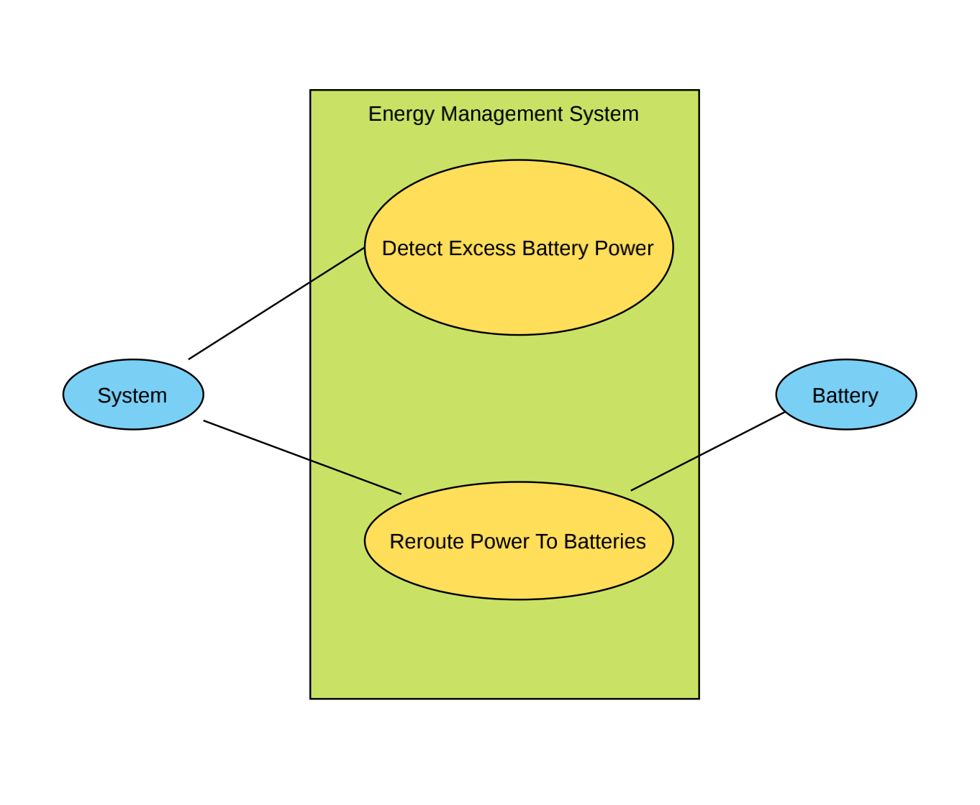

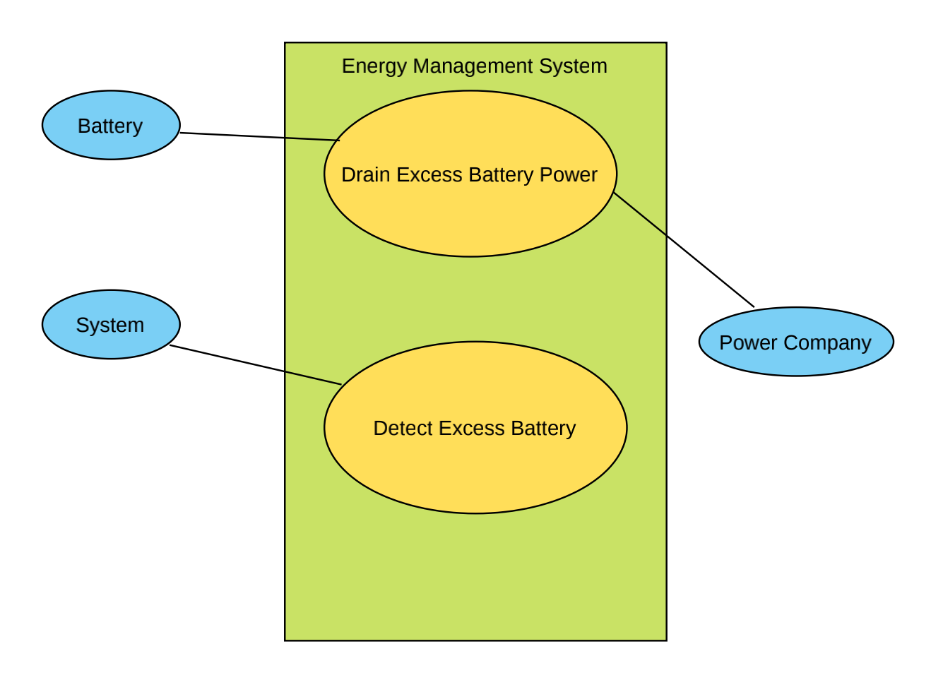

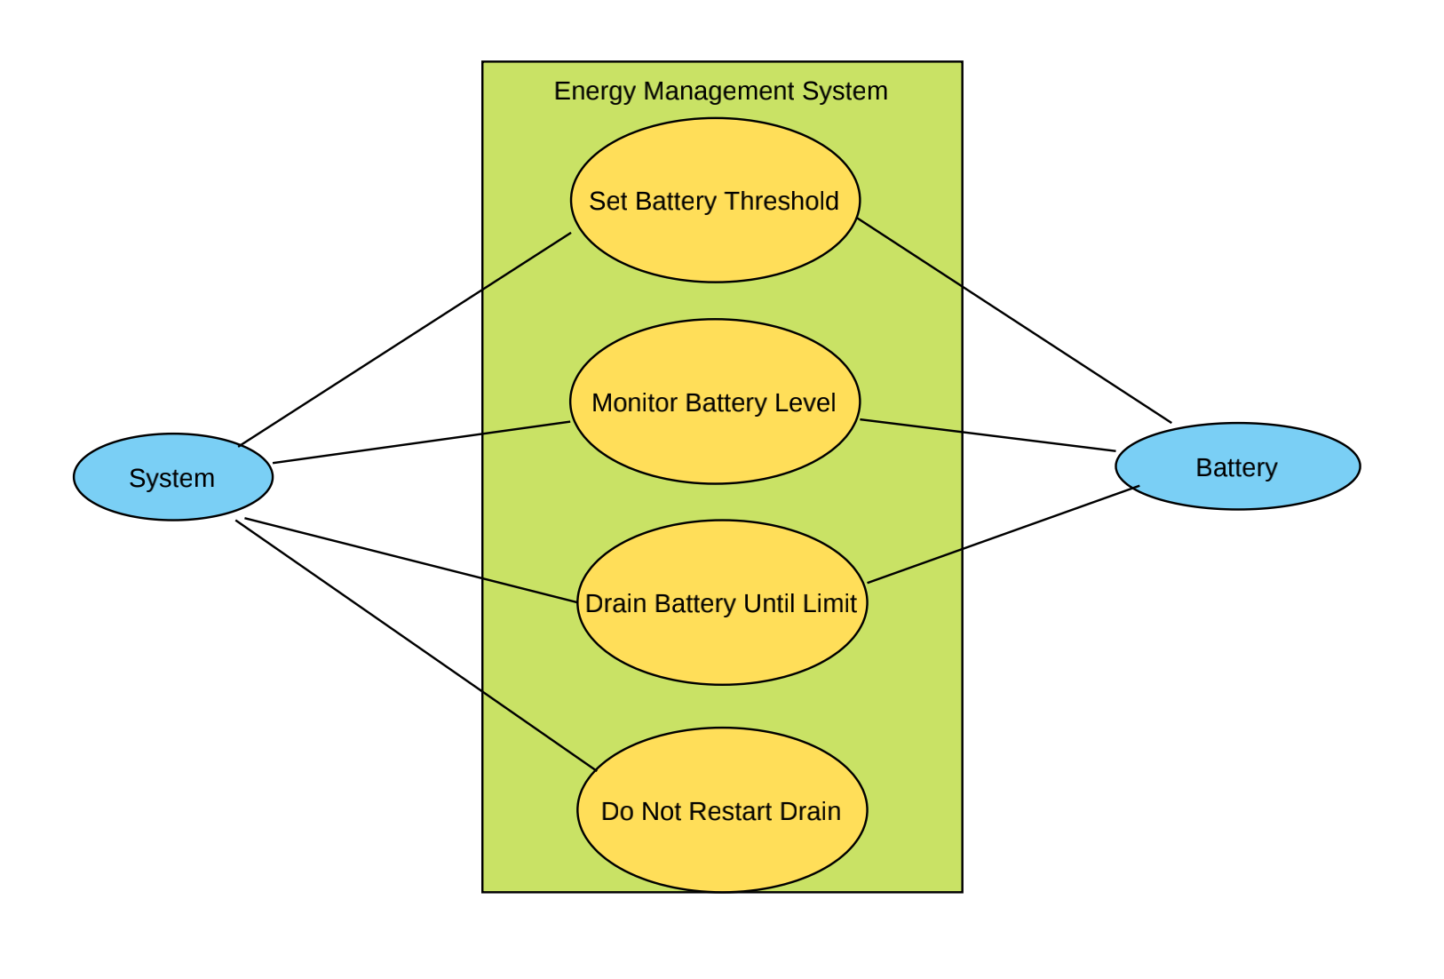

## **Architecture**



## **Non-Functional Requirements**

* System must have a 99.99% or higher uptime rate
* User must be able to interact with the system on a casual basis
* System must be able to bear multiple alternate sources of energy

## **Object Class Diagram**

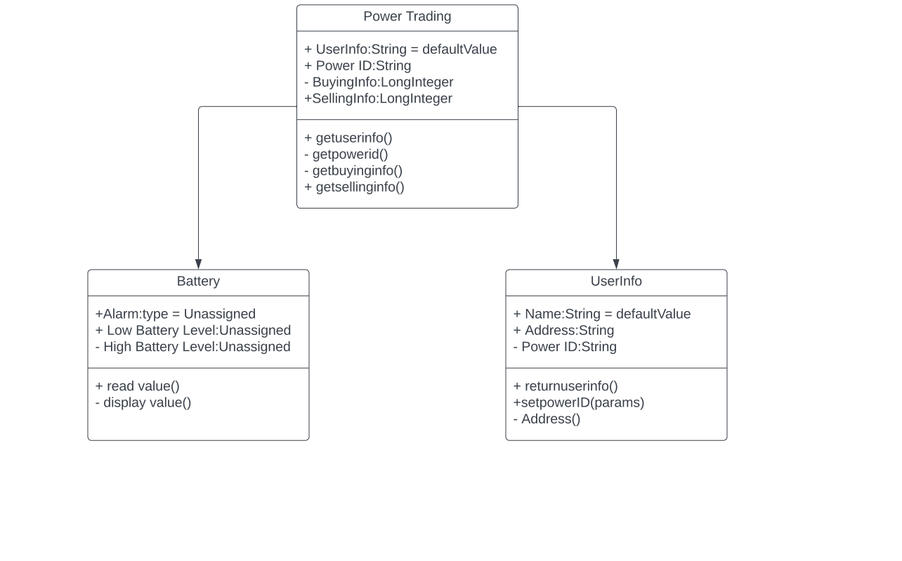

## **Test and Evolution Planning**

**Initial Phase:**

Initial phase includes testing during the development as our model adapts TDD (Test-Driven Development) in which unit testing and validation testing is done initially along with the development of features. If the phase passes the test, then it is marked as completed and goes on to next tests.

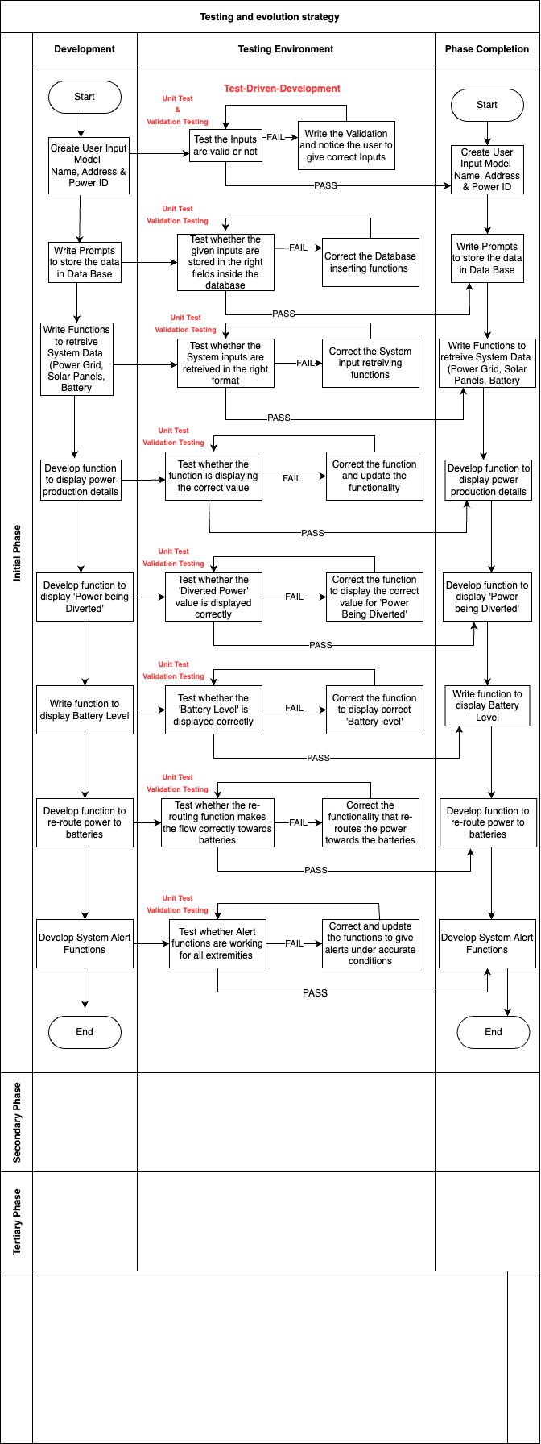

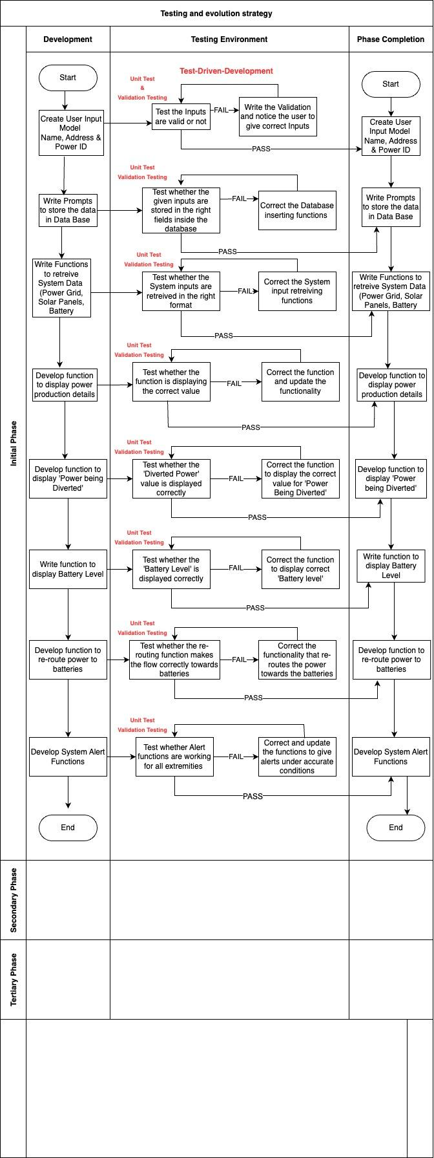

**Secondary Phase:**

Secondary Phase includes Component testing and Interface testing

Component testing covers these errors:

* Interface Misuse
* Interface Misunderstanding
* Timing Errors

Interface testing is done because it ensures that an end-user does not face or encounter any major or minor hindrance while using a particular software or application.

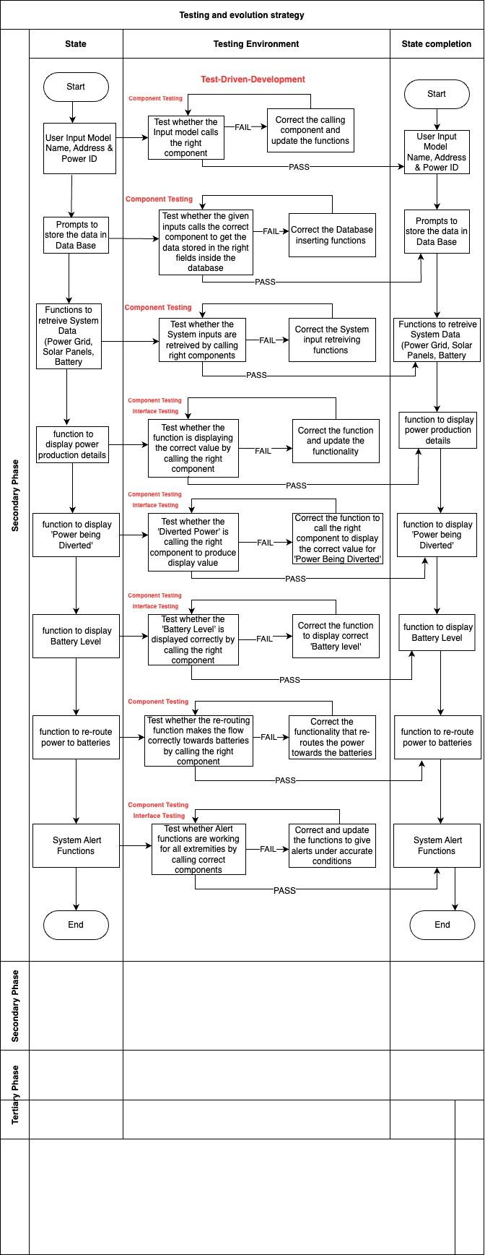



**Final Phase:**

Final phase of testing includes acceptance testing in which every functionality is tested for acceptance by the developers and the user. If the functionality passes the test, then it is forwarded to deployment testing and when it passes that level, the functionality is deployed. If the function does not pass the deployment testing, then it’s reverted back to the acceptance testing phase.

Acceptance tests cover the following attributes:

* User Stories
* Acceptance Criteria
* Use Cases

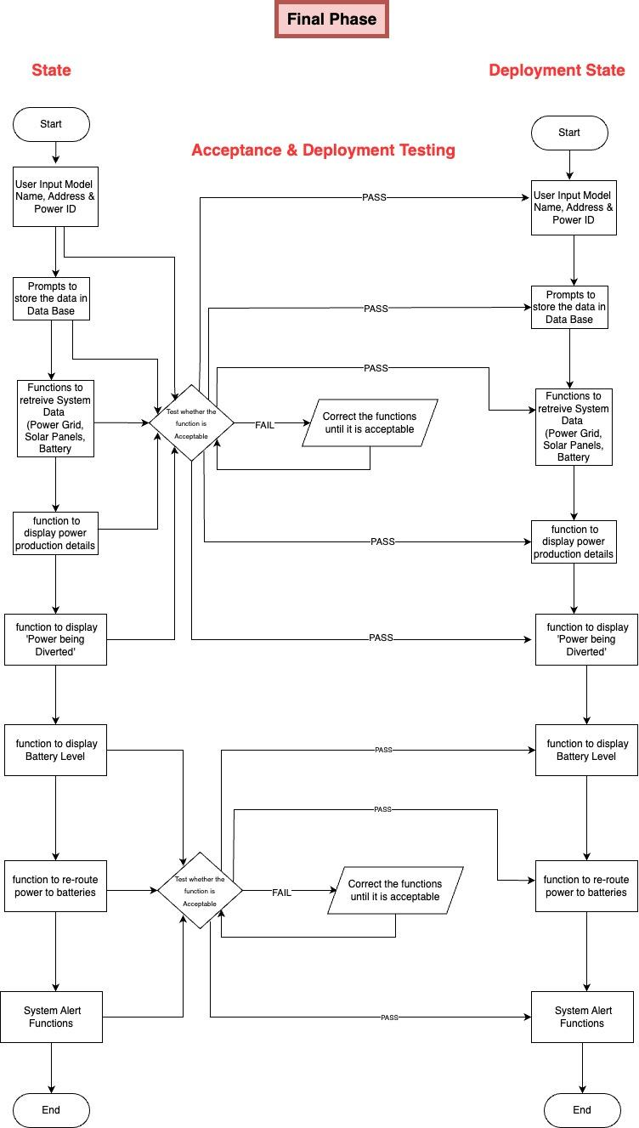

Diagram Continued on the next page



**Maintenance Plan:**

Maintenance plan includes three main attributes. They are predicting maintainability, Predicting System Changes and Budget Plan

**Predicting Maintainability & System Changes:**

Maintainability prediction validates which part of the system will be most expensive to maintain, here we categorized those parts into High, medium and low priority components. Similarly System changes are sorted according to requests

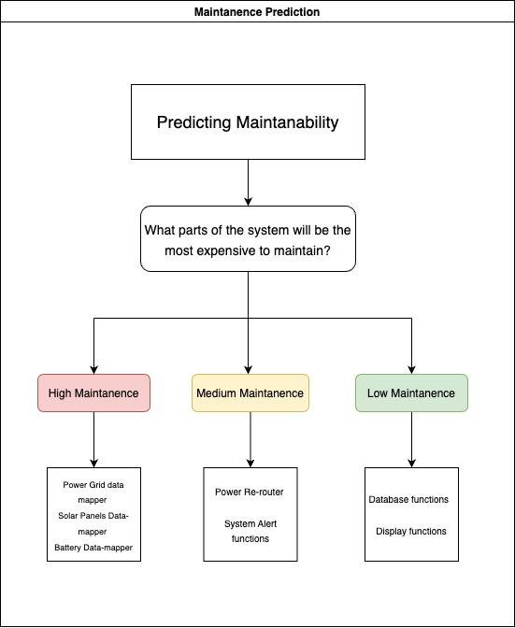

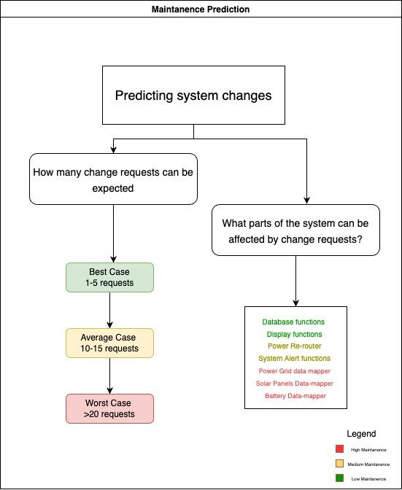

**Budget Breakdown:** 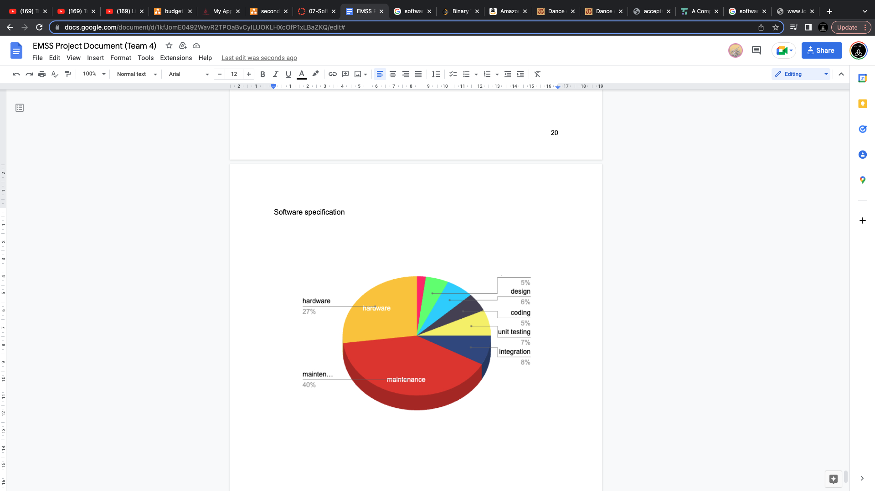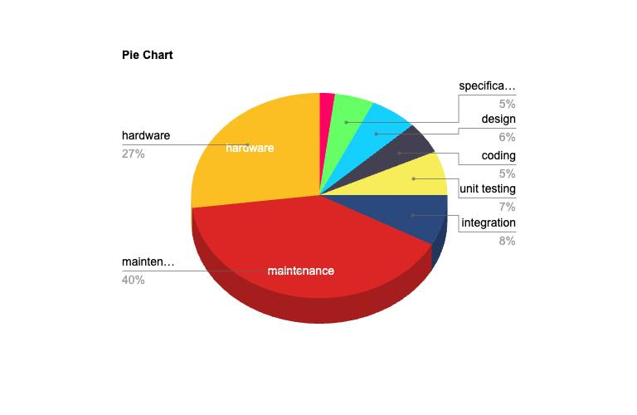

## **Measurement Plan**

1. Planning
   1. Trello
      1. Enables the use of Kanban Principles.
      2. Visual representation of work done.
      3. Measures task throughput.
      4. Measures low throughput areas.
2. Organization
   1. Jira
      1. Enables the use of Agile Principles
      2. Assignment of development tasks
      3. Work monitoring
      4. Measures team efficiency
3. Version Control
   1. GitHub
      1. Version control
      2. Version branching
      3. Individual member contribution
      4. Measures issue tracking and resolution
      5. Measures high tracked areas
      6. Measures improvement needs

## **Reliability and Availability Requirements and Measurement**

**Software Reliability:**

The likelihood that software will operate faultlessly for a predetermined amount of time in a predetermined environment is known as software reliability. System reliability is significantly influenced by software reliability as well. In contrast to hardware reliability, it emphasizes design excellence rather than manufacturing excellence by calculating in accordance with the number of assets present in the project.

**Assets in our project:**

* Database input prompts
* System data retriever
* Solar-Panels data mapper
* Power grid Data mapper
* Power production data display
* Power Diverted data display
* Battery level data display
* Power rerouter
* System Alert functions

**Total Number of Assets ~ 9**

Let’s have the **hours of operation as 5,000** for example

**Downtime** depends on the following factors in our project:

**Human error**: Human mistake is one of the main reasons for unplanned downtime, whether it is unintentional or the result of carelessness. Costly downtime might result from an user/admin accidentally unplugging a cable, accidentally deleting data, or not adhering to regular procedures. (Ex: entering wrong inputs for power data)

**Hardware / software failure**: Application failure and system outages are more likely to occur when hardware or software is outdated. Ineffective performance from outdated technology and software also has a negative impact on productivity. (Ex: power re-router has stopped working)

**Device misconfiguration:** Misconfigured devices are a significant contributor to unplanned downtime. Your network may become vulnerable to cyberattacks due to configuration mistakes that lead to security weaknesses. Instead of manually setting the parameters, you can automate the process to prevent configuration problems. (Ex: Battery level data breach by external attacks)

**Bugs**: Operating system bugs in servers can affect their performance as well as create security problems. Patches can corrupt programs and cause server failure if they aren't applied on schedule or without the proper testing. (Ex: faults in power calculation algorithm)

**Cybersecurity threats:** One of the most serious and frequent sources of IT downtime, cyberthreats, including sophisticated ransomware and phishing assaults, can put your business at a stop. Malicious actors can quickly take advantage of weaknesses in your network to infiltrate systems, access sensitive data, and more.

**Natural disasters:** Natural calamities like hurricanes, floods, and earthquakes can interfere with communication and the electrical grid and even harm electronics. If the downtime lasts for a long time, it could have disastrous effects on our product.

While down-time is unavoidable, it can be monitored and prevented using following actions

* Developing a disaster recovery plan
* Ensuring our hardware / software devices are up-to-date
* Testing all the backups regularly
* Constantly monitoring our data resources, network and associated devices
* Training the users with latest updates

Software reliability heavily depends on the calculation of software reliability metrics

**Software reliability Metrics:**

* Mean Time to Failure (MTTF)
* Mean Time to Repair (MTTR)
* Rate of occurrence of failure (ROCOF)
* Mean Time Between Failure (MTBF)
* Probability Of Failure On Demand (POFOD)
* Availability (AVAIL)

**Mean Time to Failure (MTTF):**

MTTF looks at how much time has elapsed between two failure occurrences, and it’s averaged over the total number of failures

Formula of **MTTF** = Total hours of operation / Total assets in use

**MTTF in our project:**

MTTF = 5,000 / 9

**MTTF = 555.55 hours**

We can conclude that the average lifespan of our assets is around 555 hours

**Mean Time To Repair (MTTR):**

MTTR is the average time that it takes to repair something after a failure

Formula of **MTTR** = Total down Time / number of breakdowns

**MTTR in our project:**

As total down time can not be predicted, as we discussed earlier it depends on several factors, but for example, on a average, if a system breaks down for 5 times per 1000 hours and let’s say the downtime is around 1 hour, it gives **25 breakdowns for 5,000 hours** and the **down time is 25 hours**, then MTTR can be calculated as follows**.**

MTTR = 25 breakdowns / 25 hours

**MTTR = 1 hour**

We can conclude that the average time taken to recover is 1 hour

**Rate of occurrence of Failure (ROCOF)**

ROCOF (rate of occurrence of failures) is the probability that a failure occurs in a given time interval.

Formula of **ROCOF** = Number of Items Failed / Total time taken

**ROCOF in our project:**

As number of items failed can be unpredictable too, let’s say there are **5 failures** over the span of **5,000 operating** hours

ROCOF = 5 / 5000

**ROCOF = 0.001**

We can conclude that rate of occurrence of failure is 0.001

**Mean time between Failure (MTBF)**

When a component, assembly, or system fails, the MTBF is the amount of time that has passed, assuming a constant failure rate. Simply, it is the inverse of ROCOF

Formula of **MTBF** = 1 / (Number of Items Failed / Total time taken)

**MTBF =** Total time taken / Number of Items Failed

**MTBF in our project:**

As number of items failed can be unpredictable too, let’s say there are **5 failures** over the span of **5,000 operating** hours

MTBF = 5000 / 5

**MTBF = 1,000 hours**

We can conclude that the average time between a failure is 1,000 hours

**Probability of Failure on Demand (POFOD):**

the unreliability of that component or system is referred as the probability of failure on Demand

Formula of **POFOD =** 1 - Dependability

**POFOD in our project:**

Let’s analyze the POFOD our project in three different scenarios

**Best Case:**

In best case, let’s say the dependability of our project is high, **99.9% (0.999)**

POFOD = 1 - 0.999

**POFOD = 0.001**

**Average Case:**

In best case, let’s say the dependability of our project is high, **95% (0.95)**

POFOD = 1 - 0.95

**POFOD = 0.05**

**Worst Case:**

In best case, let’s say the dependability of our project is high, **90% (0.90)**

POFOD = 1 - 0.90

**POFOD = 0.1**

Therefore, we can conclude that POFOD can vary with the dependability of our projectwhich also varies with several use cases we defined earlier

**Availability (AVAIL) :**

The probability that a system, at a point in time, will be operational and able to deliver the requested services

**Calculating Availability:**

Availability, as a measure of uptime, can be calculated as follows:

**Percentage of availability** = (total elapsed time – sum of downtime) / total elapsed time

Elapsed time = Actual time taken while particular event is occurring

Total downtime = Total number of minutes in a given calendar month that the site is not available

**Calculating Availability assuming no planned downtime for our project**

| **Availability Level** | **Allowed unavailability window** |
| --- | --- |

|  | Per Year | Per Quarter | Per Month | Per Week | Per Day | Per Hour |
| --- | --- | --- | --- | --- | --- | --- |
| 90% | 36.5 days | 9 days | 3 days | 16.8 hours | 2.4 hours | 6 mins |
| 95% | 18.25 days | 4.5 days | 1.5 days | 8.4 hours | 1.2 hours | 3 mins |
| 99% | 3.65 days | 21.6 hours | 7.2 hours | 1.68 hours | 14.4 mins | 36 secs |
| 99.5% | 1.83 days | 10.8 hours | 3.6 hours | 50.4 mins | 7.20 mins | 18 secs |
| 99.9% | 8.76 hours | 2.16 hours | 43.2 mins | 10.1 mins | 1.44 mins | 3.6 secs |
| 99.95% | 4.38 hours | 1.08 hours | 21.6 mins | 5.04 mins | 43.2 secs | 1.8 secs |
| 99.99% | 52.6 minutes | 12.96 mins | 4.32 mins | 60.5 secs | 8.64 secs | 0.36 secs |

The number of users affected due to an outage and the length of the outage are not taken into account.

## **Safety, Security and Resilience:**

**Threats to EMSS Reliability:**

1. During our development process the development should take into consideration certain cases that may affect the long-term operation of the project. For example certain failures in the tracking of power consumption (i.e. a test of software resilience in the form of data corruption by programming error or outside malicious attackers) over time can lead to power generation down the line.

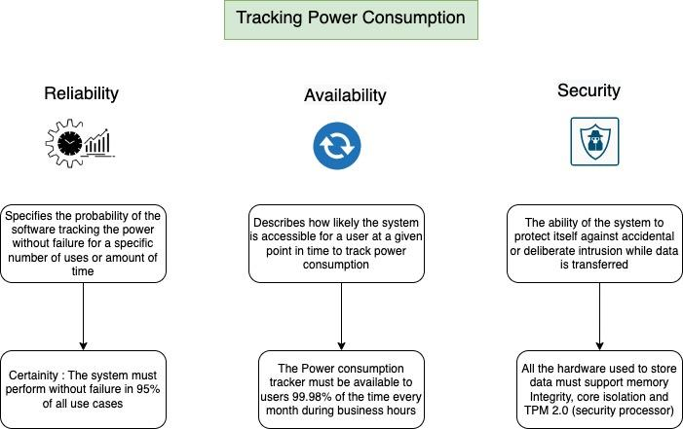

2. Failure through program error to accurately track consumption/selling of power is a major issue. If the software we are running to communicate to the power grid the need to receive or sell off power goes down then we can experience a severe failure in our program.

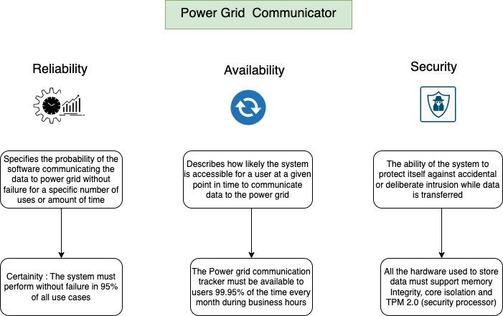

**Safety Configuration of our EMSS:**

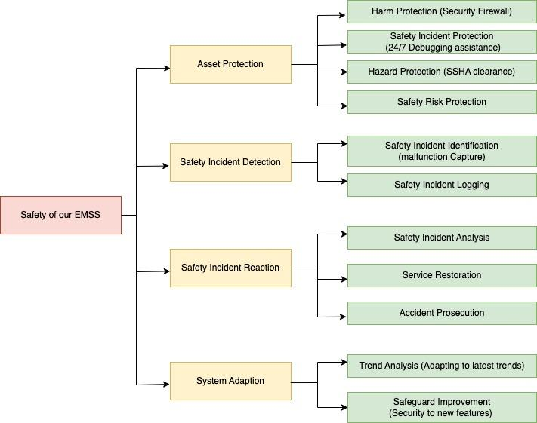

**Mitigating Risk:**

1. To Mitigate the Risk to Hardware:

i). If we see a catastrophic environmental event (earthquake damages delicate hardware or ash darkens the sky for extended periods of time limiting the solar power received) we would want our software to implement a redundancy that would see power converting to a limited alternative source (i.e. our secondary generator).

ii). Additionally we should want to try to diversify the channels in which data is stored to our database. A good idea is to send information in time-delayed sequence. For example, we can track the consumption of power on certain preset increments. We can have two functions to simultaneously track the data. One function can send data for energy tracking initially. The second function will ‘hold’ that data and then after a preset time check to see if the data sent from the first function made it over successfully. If it did not that function will update the data stored. If the data was stored accurately then the function will ‘dump’ that data and resume tracking.

iii) If our panels get disconnected from the

2. To Mitigate the Risk to Software:

i). If we have a critical error to our software such as stack overflow or pointer corruption

ii). A development could be an error to the update of power flow due to a software bug (power wasn’t distributed on the normally scheduled time due to an edge case such as Daylight Savings Time interrupting the regularly timed code). This would cause a system error.